Te vuelva a subir DRALO

Writing Feedback UX Specification
Layer 4 · Feedback presentation and interaction
Version 1.0 · 9 August 2026
Official handoff-ready product specification

Document Metadata
Document ID | 04
Document Name | DRALO — Writing Feedback UX Specification
Version | 1.0
Status | Vigente — UX architecture approved; implementation pending
Last Updated | 2026-08-09
Knowledge Source | Feedback UX interview and approved Writing feedback mock-ups in the DRALO project
Scope | Visible presentation, sequencing and interaction of Writing correction feedback
Related Documents | 01 — Task Requirements; 02 — DRALO Teacher DNA; 03 — DRALO Cambridge Assessment
Dependencies | Current DRALO Writing UI and design system for final visual implementation
Supersedes | Previous informal Feedback UX notes and mock-up-only discussion
Owner | Por definir
Review Required | Yes — implementation acceptance review after Cursor build
Documentation Standard | DRALO Specification Template v1.0

KEY CLARIFICATION — The interview and mock-ups already defined the substantive content of Layer 4. This document formalises those approved decisions; it does not restart the UX interview.

1. Purpose and authority
This document defines how the intelligence produced by the DRALO Writing Assessment Engine is experienced by the student. It is the fourth layer of the Writing engine and governs presentation, sequencing, interaction and progressive disclosure. It does not redefine Cambridge scoring, task requirements or pedagogical judgement.
- 01 — Task Requirements defines what the task requires.
- 02 — Teacher DNA defines what DRALO notices, prioritises and explains pedagogically.
- 03 — Cambridge Assessment defines marks and examiner reasoning.
- 04 — Writing Feedback UX determines how those outputs are surfaced to the learner.
The Feedback UX may simplify, sequence or progressively reveal explanations, but it must never alter the underlying Cambridge mark or its evidential basis.

2. Foundational Experience Principles

Principle #1 — The Interactive Writing Map
El Writing no debe presentarse como un documento estático que recibe comentarios externos. Debe convertirse en un mapa interactivo de aprendizaje donde cada subrayado representa una oportunidad de descubrir, comprender y recordar. El estudiante no lee un informe: explora su propio texto.

Principle #2 — The Writing is the Interface
La interfaz debe ser tan limpia y evidente que el alumno no necesite aprender a utilizarla. Su atención debe dirigirse desde el primer segundo a explorar su propio writing, no a entender la herramienta.

Principle #3 — Everything Starts from the Writing
Nada debe competir visualmente con el writing. Todas las explicaciones, fortalezas, sugerencias y recursos nacen del propio texto y vuelven a él. El writing es el centro absoluto de la experiencia.

Principle #4 — Exploration, not Consumption
El feedback no se consume de forma pasiva. Se descubre. Cada interacción debe invitar al alumno a explorar su writing con curiosidad, igual que quien recorre un mapa buscando información.

Principle #5 — Teacher, not AI
En ningún momento el estudiante debe sentir que está leyendo una respuesta generada por una inteligencia artificial. Toda la experiencia debe transmitir la sensación de estar recibiendo una tutoría personalizada de un profesor experto con años de experiencia.

Principle #6 — Positive Reinforcement First
El objetivo del feedback no es demostrar los errores del alumno, sino ayudarle a comprenderlos sin perder la motivación. La experiencia debe comenzar reforzando aquello que ha hecho bien y terminar con una sensación clara de progreso y de saber cuál es el siguiente paso.

3. Approved page architecture and storytelling
The approved experience follows a writing-first hierarchy. The page is not a dashboard followed by a corrected text; the corrected text is the primary product surface, while scores and explanatory layers remain secondary.
3.1 Initial state — clean interactive map
The writing is visible immediately and remains visually dominant. Feedback-bearing spans are available from the start but represented discreetly. The default page must not look like a document covered in corrections.
3.2 Positive opening — 2–3 strengths
Two or three especially valuable strengths receive additional prominence at entry. This is a deliberate exception to the otherwise restrained map state and implements Positive Reinforcement First without turning the experience into a guided tutorial.
3.3 Global Cambridge result — visible but secondary
A concise global mark such as “15/20” is visible in the upper area of the page. It must be easy to find but must not compete with the writing. A level indicator may accompany it when supported by the scoring layer.
3.4 Interactive Writing Map — primary exploration
The learner clicks marked fragments in the writing to reveal local feedback. This is the core interaction and the primary route into the correction.
3.5 Cambridge criterion feedback below the map
Below the writing, the four Cambridge criteria — Content, Communicative Achievement, Organisation and Language — receive their own feedback areas. The overview is concise; the detailed layer can be expanded.
3.6 What to review next
After the criterion feedback, DRALO presents a short list of concepts worth reviewing, such as a grammar point, vocabulary area, cohesive-device issue or other reusable learning target. In v1 these are plain-text concepts without links.
3.7 Final CTA — Write another task
The current end-of-flow action is to attempt another Writing task. Saving progress as a prominent CTA and linked study-material actions are not included in the current version because the relevant product areas are not yet sufficiently developed.
Approved storytelling: Writing → discreet global result + 2–3 strengths → interactive exploration → criterion-level feedback → review-next concepts → Write another task.

4. Progressive disclosure model
Visual simplicity must not become pedagogical simplicity. DRALO should expose the depth created by Task Requirements, Teacher DNA and Cambridge Assessment in layers, so the student can obtain a fast overview or inspect the reasoning in depth without leaving the writing experience.

4.1 Criterion cards / sections
- Collapsed or summary state: criterion name, mark, and a compact but meaningful diagnosis.
- Expanded state: a more substantial personalised explanation tied to the student response.
- The detailed state should explain what worked, what is limiting the score, relevant evidence from the student text, and what would move the performance towards the next band when the evidence supports that distinction.
- Generic one-line comments are placeholders only in mock-ups and are not an acceptable implementation target.
Criterion feedback must use progressive disclosure. A clean card is a presentation decision, not a reduction of the intelligence available from Layers 1–3.

4.2 Expected depth of criterion feedback
The final system should be capable of producing comments materially richer than those shown in the visual mock-up. The short visible summary should be readable at a glance; the expanded explanation should demonstrate examiner reasoning and teacher-like diagnosis. The Feedback UX must preserve this distinction.

5. Interactive annotation behaviour

5.1 Trigger
- Feedback opens on click / tap.
- No hover preview is used in the approved desktop experience.
- The reason is focus: hover-triggered content risks turning exploration into visual distraction.

5.2 Adaptive bubble content
The amount of content in a local annotation depends on the type of issue. Every bubble should go to the point; not every correction needs an explanation of equal length.
Feedback type | Local bubble behaviour
Simple spelling / typo | Show the corrected form. Add explanation only if it has learning value.
Single-word improvement | Show the suggested word or phrase plus a concise reason when useful.
Grammar issue | Name or explain the grammatical problem in learner-friendly language and suggest a corrected or improved structure.
Connector / organisation issue | Explain what is unclear or ineffective in the connection and show a clearer alternative or structural suggestion.
Strength | Explain briefly why the selected fragment works and what the learner should retain or reuse.

Token consumption was explicitly identified as an implementation constraint to measure. The UX requirement is concision and adaptive depth; token budgets must be validated in the technical handoff rather than solved by flattening all feedback to the same length.

5.3 Bubble opening and closing
- Default behaviour: clicking a second annotated span closes the currently active bubble and opens the new one.
- The learner should not accumulate a large stack of open bubbles during normal exploration.
- The interview expressed a desire to allow more than one bubble to remain open in some form, but the mechanism for doing so was not defined. This capability is therefore not part of the default v1 interaction contract and must not be invented by Cursor.
Default v1 interaction = one active bubble at a time. Multi-open capability remains unresolved unless a later interaction is explicitly approved.

6. Mobile correction interaction
The broader mobile experience still requires product-level refinement, but the correction interaction itself has an approved direction.
- Tapping an annotated span opens a bottom sheet / slide-up panel from the lower edge of the screen.
- The panel presents the same adaptive feedback content as the desktop bubble.
- The interaction should preserve enough context for the learner to understand which part of the writing is being discussed.
- Exact panel height, snap points, drag behaviour and responsive breakpoints are implementation details to validate against the current DRALO mobile layout; they were not fixed in the interview.
Mobile local feedback uses a slide-up / bottom-sheet pattern. Exact dimensions are not approved and must follow the current DRALO responsive system.

7. Semantic marking and colour legend
Annotated spans are visually differentiated by feedback type using a semantic colour legend. The interview confirms that a legend had already been discussed, but the exact mapping and production hex values are not recoverable from the current interview record. They must not be re-invented from the generated mock-up.
- Colour communicates category/type and supports exploration.
- Underline/marking should remain discreet enough to preserve the “clean map” principle.
- The generated mock-up demonstrates the concept of category-coded marks, not the approved production palette.
- Exact colours must be taken from the previously approved legend if located, or explicitly approved before implementation.
Do not treat the mock-up colours as source of truth. Exact semantic colour assignments are Pending.

8. Visual compatibility with the existing DRALO product
The architecture shown in the approved mock-up is useful; its visual skin is not authoritative. The first mock-up was generated without a full audit of the live DRALO design language. Cursor must therefore implement the architecture inside the existing product system rather than reproduce the mock-up styling literally.
The current DRALO UI and code are the visual source of truth. Where a mock-up conflicts with existing DRALO components, spacing, typography, navigation, tokens or base palette, existing DRALO wins unless a specific redesign decision is separately approved.
- Reuse existing DRALO navigation and page shell.
- Reuse existing typography, container widths, spacing scale, card language, radii, shadows and primary CTA styles where equivalents exist.
- Reuse existing design tokens / CSS variables / Tailwind theme where present.
- Do not introduce a new global palette merely because the mock-up contains one.
- New semantic feedback colours must be additive and compatible with the existing system.
- The mock-up defines hierarchy, component relationships and interaction intent; it is not a pixel-for-pixel design system replacement.

9. Approved conceptual mock-up
The following image is retained as a conceptual reference for page architecture. It captures the writing-first hierarchy, strengths strip, discreet score, interactive map, criterion layer, review-next area and final CTA. Text inside the criterion cards is placeholder-level and the visual styling must be reconciled with current DRALO before implementation.
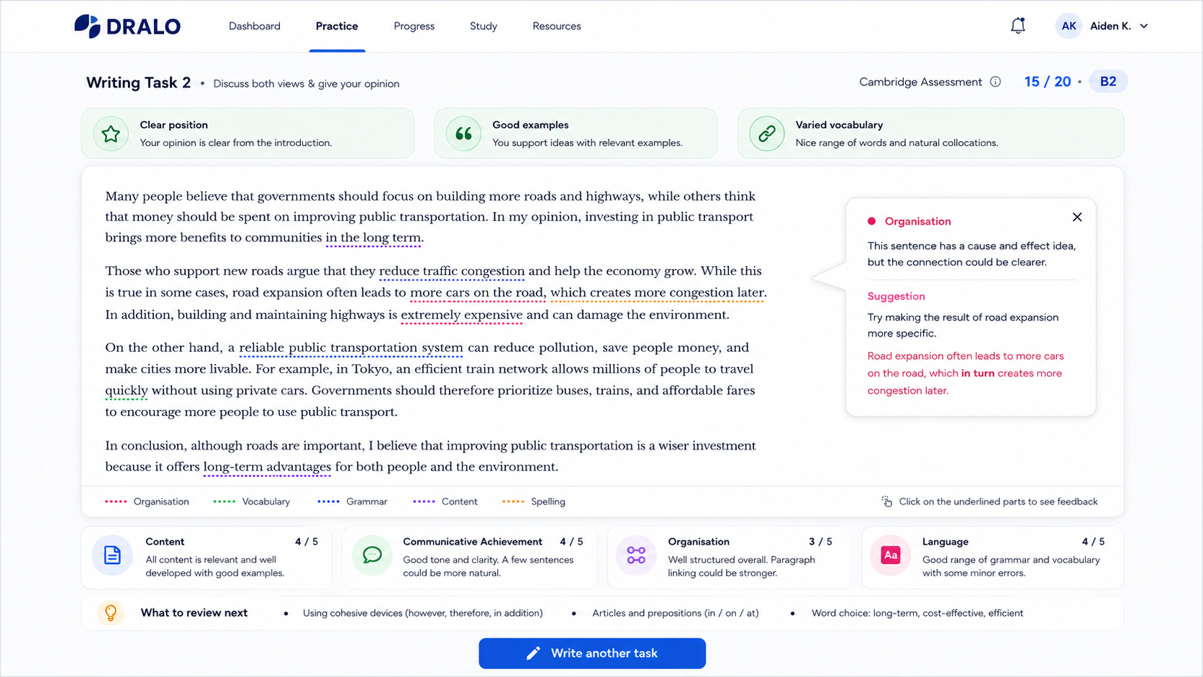
Figure 1 — Conceptual Writing Feedback UX mock-up. Architecture approved; visual skin and placeholder copy are not production source of truth.

10. Logical feedback content contract
This is a logical content contract for the UX layer, not the final JSON or API schema. The technical handoff may translate it into fields, types and validation rules without changing the user-facing intent.
Global result | Overall Cambridge mark and optional level indicator supported by Layer 3.
Opening strengths | 2–3 high-value strengths selected for positive entry into the map.
Inline annotations | Span-linked feedback items with category/type, local explanation and suggested change where appropriate.
Criterion feedback | Content, Communicative Achievement, Organisation and Language; mark + concise diagnosis + expandable detailed explanation.
Review next | Short list of reusable concepts to revisit.
Final action | Write another task.
Evidence linkage | Where feedback makes a substantive claim about the response, the engine should be able to tie it back to relevant student text or task evidence.

11. Future-facing constraints
The current design should not block later expansion. These items were explicitly discussed as future directions, not current implementation requirements.
- Writing Mentor.
- Linked teaching materials.
- Exam Strategies.
- Student progress and evolution.
- Gamification.
- Sharing corrections.
- Writing history.
- Comparing writings.
- Conversational tutor.
The “What to review next” list is intentionally link-free in v1, but its structure should allow future conversion into linked DRALO learning resources.

12. Current-version non-goals
- No full student-profile redesign is defined by this specification.
- No prominent “Save progress” end action is required in v1.
- No linked teaching-material journey is required in v1.
- No hover-based desktop feedback is required.
- No pixel-perfect recreation of the generated mock-up is required.
- No visual redesign of unrelated DRALO navigation or product areas is authorised by this document.

13. UX implementation acceptance checklist
- ☐ The writing is the largest and most visually dominant content surface.
- ☐ The initial writing state is clean rather than saturated with correction UI.
- ☐ 2–3 strengths receive positive prominence at entry.
- ☐ The global Cambridge result is visible but secondary.
- ☐ Inline feedback opens only on click/tap; no hover preview.
- ☐ Desktop local feedback is concise and adaptive to issue type.
- ☐ Opening a new local feedback item closes the default active bubble.
- ☐ Mobile local feedback uses a bottom-sheet / slide-up interaction.
- ☐ Criterion feedback exists below the writing for all four Cambridge criteria.
- ☐ Criterion feedback supports a short summary and a materially richer expanded explanation.
- ☐ The “What to review next” area is present as a simple list with no required links in v1.
- ☐ The final primary action is “Write another task”.
- ☐ Current DRALO navigation, typography, spacing, components and design tokens are reused where applicable.
- ☐ Mock-up placeholder copy is not treated as the target depth of feedback.
- ☐ No unapproved colour mapping or unrelated visual redesign has been introduced.

14. Explicit open items before or during implementation
Open item | Required resolution
Exact semantic colour legend | Locate the previously discussed legend or approve a final mapping. Do not infer it from the mock-up.
Token / cost budget for local explanations | Measure real output length and cost before choosing hard limits.
Multi-open bubble capability | The default single-active interaction is approved; any compare/pin/multi-open mechanism requires a separate decision.
Detailed mobile geometry | Panel height, snap positions and breakpoints must be reconciled with current DRALO responsive code.
Final visual audit | Inspect current DRALO Writing components and design tokens before UI implementation. The existing product is the visual source of truth.

15. Handoff boundary
This document is the approved UX/product specification for Layer 4. It is sufficiently defined to be handed to the implementation owner together with Documents 01–03. The separate Cursor implementation handoff should translate the four documents into concrete prompts, schemas, components, data flow, validations and tests. It must not re-decide the UX rules captured here.
Layer 4 content is complete enough for technical handoff. Remaining items are implementation-specific or explicitly marked open; no additional UX interview is required before Cursor can begin the audit and implementation planning.

16. Revision record
Version | Date | Status | Change
1.0 | 2026-08-09 | Vigente | Formalises the completed Feedback UX interview and approved conceptual mock-up into the official Layer 4 specification.

